Logo%20Main%20200

**Boston University**

**Electrical & Computer Engineering**

**EC464 Capstone Senior Design Project**

User's Manual

AlzLife



Submitted to

Dr. Andrey Vyshedskiy

617-817-1916

vysha@bu.edu

by

Team 9

OptiSync

Team Members

Bailey Brake [bbrake01@bu.edu](mailto:bbrake01@bu.edu)

Ruohui Huang [rhhuang@bu.edu](mailto:rhhuang@bu.edu)

Emily Lampat [lampat26@bu.edu](mailto:lampat26@bu.edu)

Khang Le [khang@bu.edu](mailto:khang@bu.edu)

Yuri Zhang [zyuri@bu.edu](mailto:zyuri@bu.edu)

:

Submitted: 4/15/2024

#### A 40Hz Light Panel

#### Table of Contents

Executive Summary 2

1 Introduction 1

2 System Overview and Installation 2

2.1 Overview block diagram for T0 model 3

2.2 Physical description 4

2.3 Installation, setup, and support 5

3 Operation of the Project - Bailey Brake 8

3.1 Operating Mode 1: Normal Operation 8

3.2 Operating Mode 2: Abnormal Operations 9

3.3 Potential Safety Issues 10

4 Technical Background 11

4.1 Technology overview 11

4.2 Technical Implementation 11

4.2.1 Device Components 11

4.2.2 Programming and Control 11

4.3 Technical Principle 11

4.3.1 Principle of 40Hz Light Stimulation 11

4.4 Conclusion 12

5 Relevant Engineering Standards 13

6 Cost Breakdown 14

7 Appendices 15

7.1 Appendix A - Specifications for T0 model 15

7.2 Appendix A - Specifications for T9 model 15

7.3 Appendix B – Team Information 16

7.4 Appendix C – T0 electronics housing model 16

(Right click on Table of Contents to update fields and page numbers automatically)

# Executive Summary

Unfortunately, many American seniors suffer from Alzheimer’s Disease or other forms of dementia. Currently, there is no cure for Alzheimer’s, and there is only management of symptoms available. Alzlife is providing an app that can be used on any smartphone that will help patients who have lowered cognitive abilities due to dementia or Alzheimer’s through interactive games. Our team deliverable is to give AlzLife an additional means of managing the decline of cognitive function for their clinical trial patients by creating a device that attaches to their phones and flashes a light at 40Hz. We will do this by programming a controller to flash an LED at 40Hz, with adjustable brightness intensities.

# Introduction

Alzheimer’s Disease, a neurodegenerative condition, has become a significant health concern, affecting over 6 million Americans and resulting in 1 in 3 seniors dying from Alzheimer’s or another form of dementia. The disease not only impacts the patients but also places a heavy burden on their families and the health care system. Early detection and intervention are crucial, yet current treatments are inconvenient and inaccessible. Many patients hesitate to seek help during the early stages of the disease, and the Primary Care Provider (PCP) often lacks the necessary resources for a timely and accurate diagnosis.

Our project introduces noninvasive sensory stimulation therapy that utilizes a 40Hz light flicker, easily attachable to the back of any smartphone, transforming it into a therapeutic device. This therapy is rooted in recent scientific findings that exposure to light flickering at a specific frequency can promote brain health by enhancing the removal of amyloid plaques - a hallmark of Alzheimer’s Disease. By having patients exposed to the light, it will promote cells and ﬂuids important for various brain waste-clearance mechanisms that are important in eliminating debris and plaques known to cause Alzheimer’s. Our LED panel, designed for simplicity and ease of use, emits a bright white light that flicks at 40 Hz. This innovation allows patients to receive treatment in the comfort of their own homes, without the need for complex machinery or frequent visits to healthcare facilities.

As we delve into the subsequent sections of this document, we will delineate the scientific foundation underpinning the 40Hz light therapy, detailing the research and evidence that supports its efficacy. Following this, we will provide a comprehensive guide on the implementation and use of the therapy, including technical specifications, user instructions, and maintenance guidelines. Finally, we will address potential challenges and safety guidelines, ensuring that users can confidently and safely incorporate this innovative therapy into their care regimen. Through this document, our aim is to equip healthcare professionals, neuroscientists, patients, and caregivers with the knowledge and tools necessary to embrace this promising new frontier in Alzheimer's treatment.

# System Overview and Installation

For this product we have 2 different models catered towards different purposes. The base model, which is the T0, is our very first version for our client’s needs, which serves to be a simple LED panel supported by a stand. The phone would be attached onto the panel using an integrated phone holder, and at the back of the panel is where the power button resides. Simply, press it and the user will be able to use their phone without having to hold it, while being exposed to 40Hz light that is proven to help with Alzheimer’s Disease and dementia. Figure 2.1.1 shows that we have the power supply being the wall outlet connected to the power module that will help power up the circuit. The panel stand will hold the LED panel, in which we have an Arduino Nano as the microcontroller connecting the hardware and software components that will act as the controller to transfer an ON/OFF signal into the LED panel.

Figure 2.1.2 is the overall system block diagram for the T9 model. It is a lot more streamlined and compact compared to the T9 model and is tailored more towards user’s convenience and needs. It has simply a phone cable that connects the phone into the microcontroller, which takes input of the brightness module and sends the corresponding signal to adjust the brightness of the LED accordingly. The software components for both models stay relatively the same as they are both compatible with Arduino code.

## Overview block diagram for T0 model

## 

*Figure 2.1.1 System block diagram of T0 model*

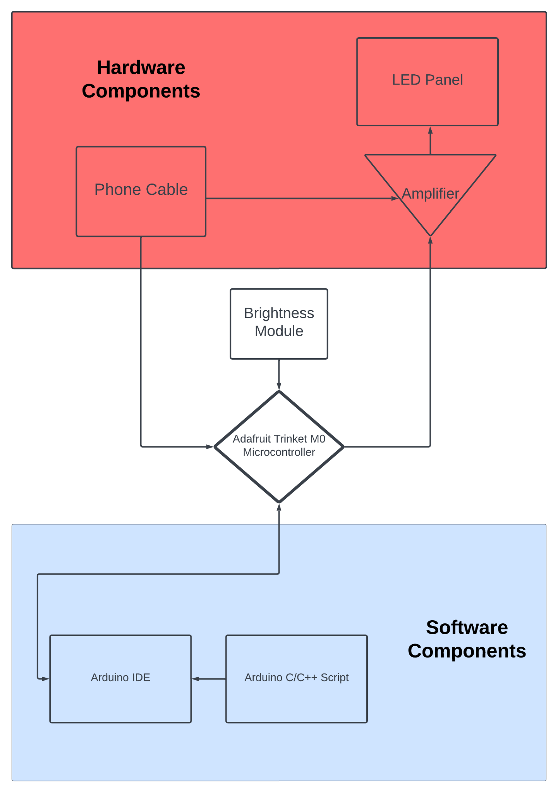

*Figure 2.1.2: System block diagram of T9 model*

## Physical description

Figure 2.2.1 below depicts the setup for the T0 model. It consists of a phone holder in the middle of the front panel, and to correctly set up the product you place the panel on top of the stand. The isometric view shows how you can do so, with the stand having 5 different angle configurations suited for the user’s needs.

Figure 2.2.2 is our current 3D design for our T9 model. It encompasses a housing for the circuit board that holds the MOSFET, Trinket M0, LED, buttons and wires. There are 2 holes that allow the user to press the buttons for brightness adjustments and a tube to cover the LED wiring that extends to support the LED strip to be at the front of the screen.

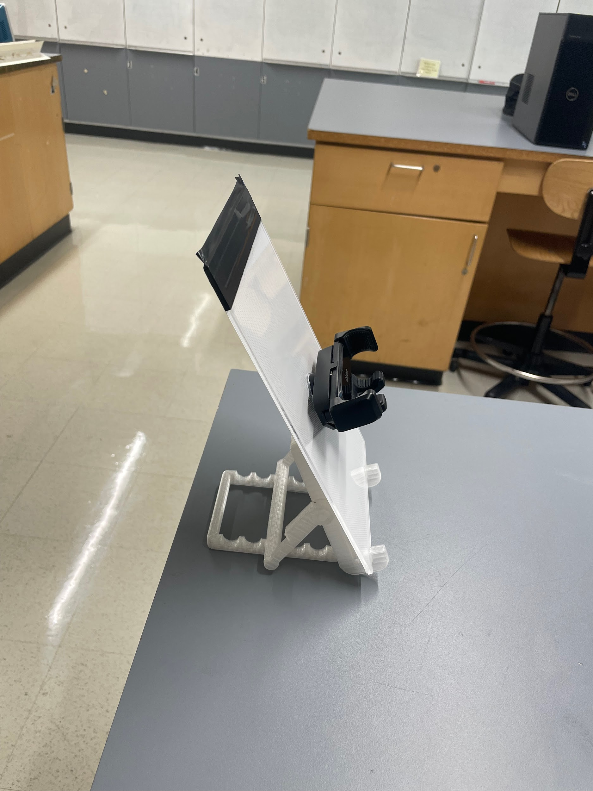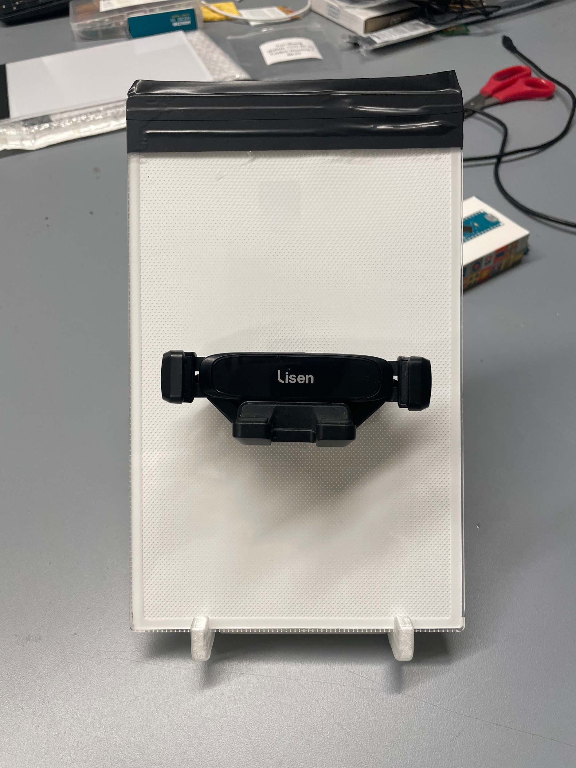

*Figure 2.2.1: Physical setup of T0 model*

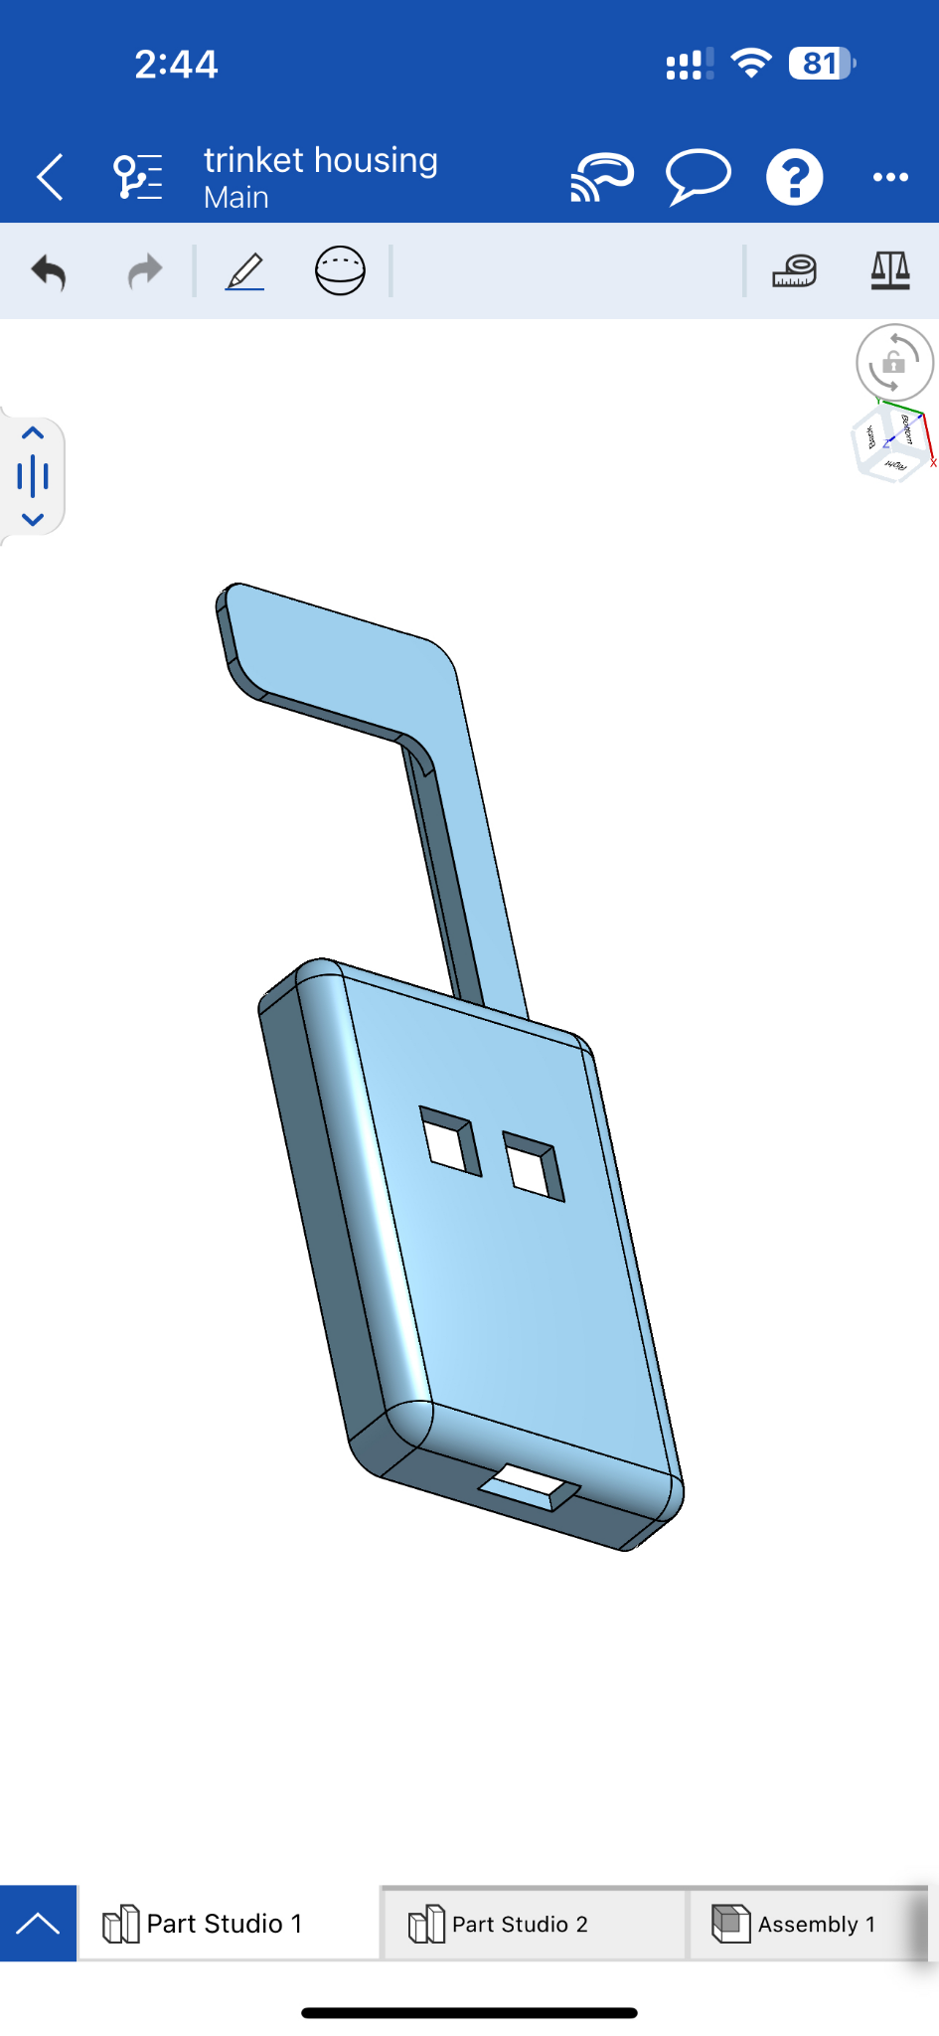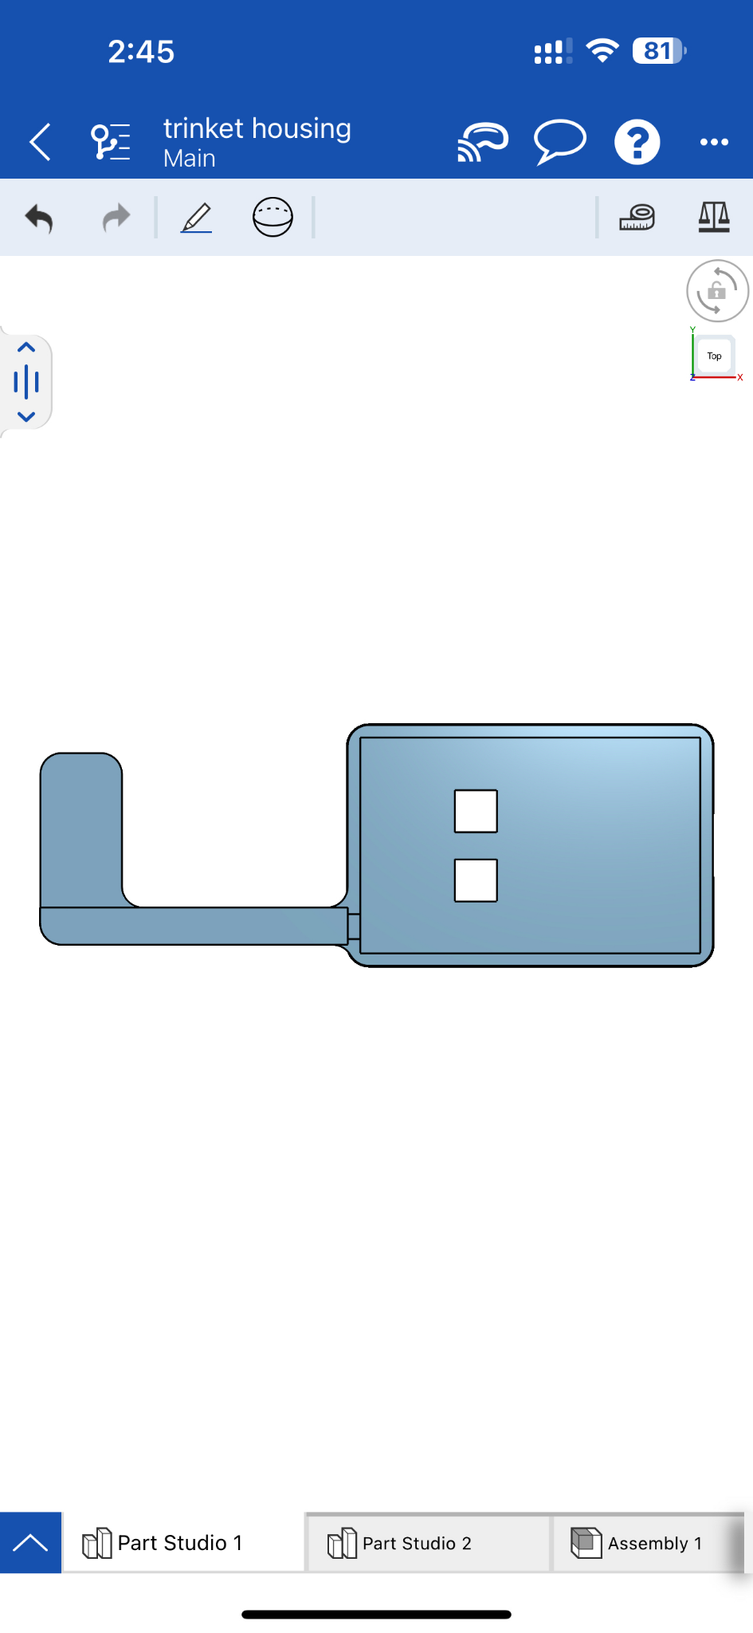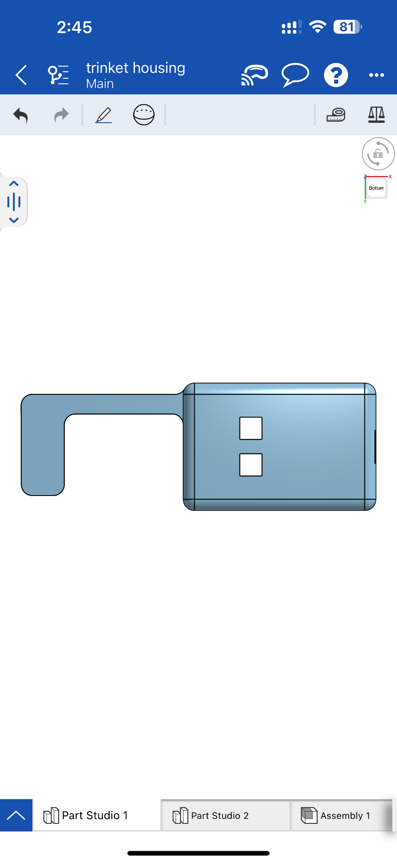

*Figure 2.2.2: Housing of T9 Circuitry*

## Installation, setup, and support

Installation: For both the T0 and T9 model, to upload the code onto its corresponding microcontroller (Arduino Nano for the T0, and Adafruit Trinket M0 for the T9), first connect your PC to the microcontroller using a provided cable. Then go to the Github repository: *insert Github link here*. From there, download the .ino file which is an executable file for your Arduino. Open Arduino IDE, and select the board by clicking Boards Manager > Arduino Nano (for the T0 model). If you are using the T9 model, you will need to install the Adafruit Trinket M0 board onto the IDE. To do this, you will click “Additional Boards Manager URLs” and copy and paste this link onto it “<https://adafruit.github.io/arduino-board-index/package_adafruit_index.json>”. If you already have pre-existing link(s) onto it, separate them with commas. Next, open Boards Manager and search Arduino SAMD, and install the latest version of “Arduino SAMD Boards (32-bits ARM Cortex-M0+) by Arduino.

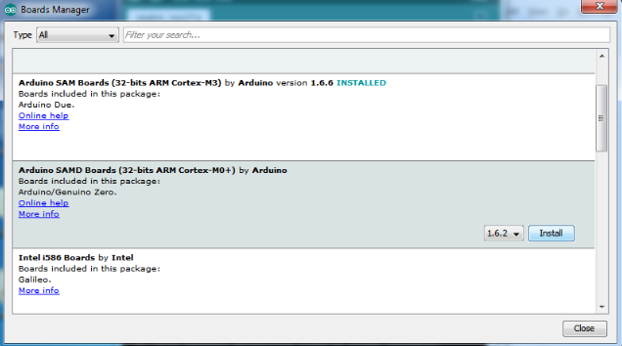

Next, search Adafruit SAMD, and install the latest version of Adafruit SAMD Boards by Adafruit. By now, you should be able to find the Trinket M0 in your list of boards.

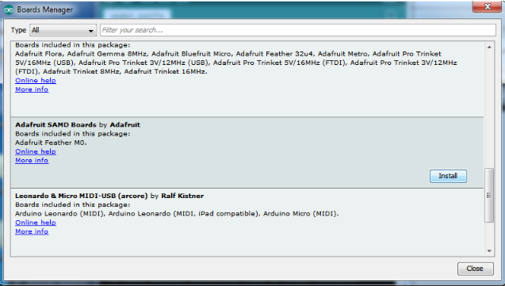

Once you have installed the Trinket M0 onto your Arduino IDE, simply open the .ino code and upload it onto the microcontroller board, and you are done with the installation.

T0 MODEL:

The panel has a frame on which it can rest. The user can place their phone in the holder attached to the panel and use their phone either resting in the stand or holding the panel. In order to turn on the system, press the button on the back of the panel. No other adjustment is needed as the frequency and brightness are already set.

T9 MODEL:

This system is more mobile and can be attached to the back of the user’s phone case so that the light rests just above the phone screen. In order to turn on the device, you plug the system into the charging port of your phone. Note that the system currently supports only devices with USB-C connection.

# Operation of the Project - Bailey Brake

## Operating Mode 1: Normal Operation

T0 MODEL:

Operating the T0 is very straightforward. After plugging the T0 into a power source and waiting briefly for the device to boot up, the T0 will turn on and the LED panel will begin flickering at 40Hz. To turn the device on and off, simply press the Power button on the back of the panel. For best results, angle the LED panel so that you are looking directly towards it. Utilize the stand included alongside the panel to achieve the desired angle, pictured below.

This is the only operation mode supported by this device. See the next section for instructions on handling abnormal operations.

To attach your phone to the panel, rest the phone on the bottom two platforms. Then gently push down until the two side platforms grip each side of the phone, holding it stationary. The attachment allows for a charger to be plugged into the phone from this position. To remove, simply pull the phone back up.

** 

*LED panel resting on angled stand Back of LED panel with labeled*

*power button*

T9 MODEL:

After installing the T9 and attaching it to the back of your phone, the device can be turned on by plugging the included cable from the T9 to your phone’s USB-C charging port. The phone will then power the device.

On bootup, use the +Brightness button to reach your desired brightness. Press the +Brightness and -Brightness buttons during use to adjust brightness. The brightness will never change automatically without user intervention. To turn the device off, hold the -Brightness button until the light is entirely off.

The range of brightness allows the device to be used inside and outside. The brightness is effectively divided into 25 intervals. The brightness buttons can either be pressed or held. Pressing a button will change the brightness by a small fixed interval. Holding down a button will smoothly scale the brightness up or down. There is no dedicated power button on the T9: rather, to turn the device off, simply hold down the -Brightness button until the light is totally off. Then turn it back on with the +Brightness button.

Note that although the light may be off, the device is still running. Additionally, if left on long enough, the device will slowly drain the phone’s battery. For maximum battery life, make sure the light is off when not in use (for instance, in your pocket) and that the device is fully unplugged when the phone is not in use for an extended time (for instance, overnight).



*T9 model with labeled brightness control*

## Operating Mode 2: Abnormal Operations

T0 MODEL:

The device should flicker at 40Hz and respond to power button inputs. If it does not respond to buttons or flickering is erratic, simply unplugging the device will cause the program to reboot. If issues persist, consider reinstalling the programming. Lastly, consider asking a technician to check on the hardware.

T9 MODEL:

Notice that on the T9 model, the brightness value for the LED is initialized to zero. This means that plugging the device to a power source does not necessarily turn the LED strip on. In addition, the bootup time for the T9 is noticeably longer than that of the T0. To turn the light on, simply press the +Brightness button to reach your desired brightness. If it does not respond, wait a few moments to ensure that bootup has completed.

## Potential Safety Issues

T0 MODEL:

The USB cable can be difficult to remove from the device. To prevent injury, take care to hold the cable by the base and pull directly out of the plug. Not adhering to this can cause damage to the cable, plug, or to the electrical connections within the device.

The LED lights used in this device are very bright and point directly down from the top of the panel to the bottom. The design of the panel takes this light and reflects it towards the user at a safe level. However, angling the panel too much can expose the user to this bright light. While not immediately dangerous, avoid prolonged exposure to direct, unfiltered light.

T9 MODEL:

The USB cable can be difficult to remove from the device. To prevent injury, take care to hold the cable by the base and pull directly out of the plug. Not adhering to this can cause damage to the cable, plug, or to the electrical connections within the device.

The T9 model connects to the user’s phone via USB-C. USB-C cables can transport both power and data. Be sure not to attempt to upload any data from the user’s phone to the device as it can cause the device’s programming to stall or become corrupted. In this case, reuploading and reinstalling the programming will be necessary to fix any issues.

# Technical Background

## 4.1 Technology overview

The AlzLife project is dedicated to the development of a non-invasive therapeutic solution to combat the progression of Alzheimer's disease through 40Hz light stimulation. This section will provide a brief overview of the technical rationale and implementation of the project, aiming to provide a clear understanding for non-technical key users.

## 4.2 Technical Implementation

### 4.2.1 Device Components

LED light source: A highly efficient and sufficiently bright LED light source was selected, keyed by its ability to deliver a precise flashing frequency of 40Hz, a characteristic based on recent research aimed at stimulating the brain to produce specific neural responses that help clear beta-amyloid proteins associated with Alzheimer's disease.

Arduino Trinket Microcontroller: This microcontroller was chosen for its compact size and simplified functionality. It is responsible for controlling the blinking frequency and brightness adjustment of the LED, which is programmed to achieve a precise blinking frequency of 40Hz.

### 4.2.2 Programming and Control

Arduino IDE: The microcontroller was programmed using the Arduino IDE to ensure that the LEDs blink at a frequency of 40Hz. This process involved writing and uploading specific scripts to the microcontroller to control the behavior of the LEDs.

Brightness Adjustment: By setting up two touch buttons, the user can manually increase or decrease the brightness of the LEDs, with a smooth transition from 0 to 255, with each button press corresponding to 10 levels of brightness change.

## 4.3 Technical Principle

### 4.3.1 Principle of 40Hz Light Stimulation

The project is based on the hypothesis that 40Hz light stimulation can promote brain gamma wave oscillations, which are closely related to cognitive functions such as attention and memory. Previous studies have shown that 40Hz sensory stimulation can reduce pathological features of Alzheimer's disease, such as amyloid accumulation, in animal models.

By precisely controlling the flashing frequency of the LED light source, the AlzLife device is designed to provide users with an easy, non-invasive treatment method. It aims to help slow down the pathological process of Alzheimer's disease by promoting the brain's natural clearing mechanisms through regular 40Hz light stimulation.

## 4.4 Conclusion

The implementation of the AlzLife program demonstrates the potential for addressing complex health challenges through technological innovation. By focusing on the core technological principle - 40Hz light stimulation - we have designed and tested a device that is both precise and user-friendly. Future directions include further iterations of the device to improve its efficiency and usability, as well as expanding our research to more fully evaluate the long-term impact of this treatment on patients with Alzheimer's disease.

# Relevant Engineering Standards

In our project, we adhered to certain engineering standards specifically for our electrical design and construction. Some safety standards when we were soldering included maintaining iron at a certain temperature range (500°F to 700°F) in order to prevent overheating. Electrical connections, especially the pins onto the processor board, were made in a neat and precise manner by ensuring the solder joints are properly formed, secured and free from defects that could compromise the electrical connection.

Furthermore, we rigorously adhered to coding standards and best practices in software design, ensuring clarity and maintainability throughout our development process. This involved employing descriptive names for variables and functions, employing modularity to isolate distinct functionalities, and adhering to camel case naming conventions. Comments were explicitly used in order for user comprehension and adaptation, as well as formatting and indentations. We avoided using excessive memory allocation to prevent memory fragmentations and crashes, done by freeing variables and not initializing too many variables. Our code is also continuously documented and integrated onto Github.

# Cost Breakdown

For T0 model:

| Project Costs for Production of Beta Version (Next Unit after Prototype) | | | | |
| --- | --- | --- | --- | --- |
| **Item** | **Quantity** | **Description** | **Unit Cost** | **Extended Cost** |
| Arduino Nano | 1 | Microcontroller | $25.00 | $25.00 |
| Prototyping board | 1 |  | $5.50 | $5.50 |
| A4 LED Light Board | 1 |  | $9.99 | $9.99 |
| Listen Phone Holder | 1 |  | $7.23 | $7.23 |
| 3D Printing Filament | 1 |  | $19.99 | $19.99 |
| Beta Version-Total Cost | | | | $67.71 |

For T9 model:

| Project Costs for Production of Beta Version (Next Unit after Prototype) | | | | |
| --- | --- | --- | --- | --- |
| **Item** | **Quantity** | **Description** | **Unit Cost** | **Extended Cost** |
| Adafruit Trinket M0 | 1 | Microcontroller | $8.95 | $8.95 |
| Prototyping board | 1 |  | $5.50 | $5.50 |
| USB powered LED strip | 1 |  | $14.99 | $14.99 |
| 3D Printing Filament | 1 |  | $19.99 | $19.99 |
| Beta Version-Total Cost | | | | $49.43 |

The difference in costs between the two models can be attributed to the specific components used, with the T0 model necessitating a more expensive microcontroller and additional elements like the phone holder and a larger LED panel. These differences between two models reflect our design considerations aimed at meeting diverse user needs, from simplicity and stability in the T0 model to mobility and convenience in the T9 model.

# Appendices

Team 9

Team Name: OptiSync Therapy

Project Name: Alzheimer’s Gamma Light Therapy

## Appendix A - Specifications for T0 model

| **Requirements** | **Value, range, tolerance, units** |
| --- | --- |
| Case Dimensions | 5.7 x 9.7 x 2.4 cm |
| Power Supply | 110V AC outlet connection with micro-usb connection |
| Running Time | ~ ∞ (until the LED burns out) |
| Cost | ~ $68 |
| User Interface | One button (on/off) for easy use |
| Visibility | Visible in a well lit room (>10 lumens) |

## Appendix A - Specifications for T9 model

| **Requirements** | **Value, range, tolerance, units** |
| --- | --- |
| Case Dimensions | 8.8 x 1.4 x 5.8 cm (18 x 2.4 x 6.8 cm with the arm) |
| Power Supply | usb-c (smartphone) to micro-usb (arduino) 3.3V |
| Running Time | ~ 6 hr |
| Cost | ~ $50 |
| User Interface | Two buttons (increase/decrease brightness) |
| Visibility | Visible in a well lit room (>10 lumens) |

## Appendix B – Team Information

Bailey Brake is a senior currently pursuing a Bachelor of Science degree in Electrical Engineering from Boston University’ College of Engineering. He is actively seeking employment right now.

**Phone number:** (603) 312-1710

**E-mail:** [bbrake01@bu.edu](mailto:bbrake01@bu.edu)

Ruohui Huang is an electrical engineering student currently pursuing a Bachelor of Science degree at Boston University’s College of Engineering, with an expected graduation date of May 2024. He is actively seeking employment right now.

**Phone number:** (631) 703-6363

**E-mail:** [rhhuang@bu.edu](mailto:rhhuang@bu.edu)

Emily Lampat is an electrical engineering student currently pursuing a Bachelor of Science degree at Boston University’s College of Engineering, with an expected graduation date of May 2024. After graduation, she will begin working full-time as an R&D electrical engineer in SPIT PASLODE, an ITW Construction unit, based out of Lake Forest, Illinois.

**Phone number:** (952) 818-5972

**E-mail:** [lampat26@bu.edu](mailto:lampat26@bu.edu)

Khang Le is a Computer Engineering student currently pursuing a Bachelor of Science degree at Boston University’s College of Engineering, with an expected graduation date of May 2024. After graduation, he is planning to pursue an MS thesis in Systems Engineering here at Boston University.

**Phone number:** (207) 632-7086.

**E-mail:** [khang@bu.edu](mailto:khang@bu.edu)

Yuri Zhang is an electrical engineering student currently pursuing a Bachelor of Science degree at Boston University’s College of Engineering, with an expected graduation date of May 2024. After graduation, he will be pursuing an MS in Electrical Engineering at the University of California Los Angeles.

**Phone number:** (469) 343-9852

**E-mail:** [zyuri@bu.edu](mailto:zyuri@bu.edu)

## Appendix C – T0 electronics housing model

## 

## 

## Appendix D – T9 model modifications

In regards to the electronics of the T9 model: 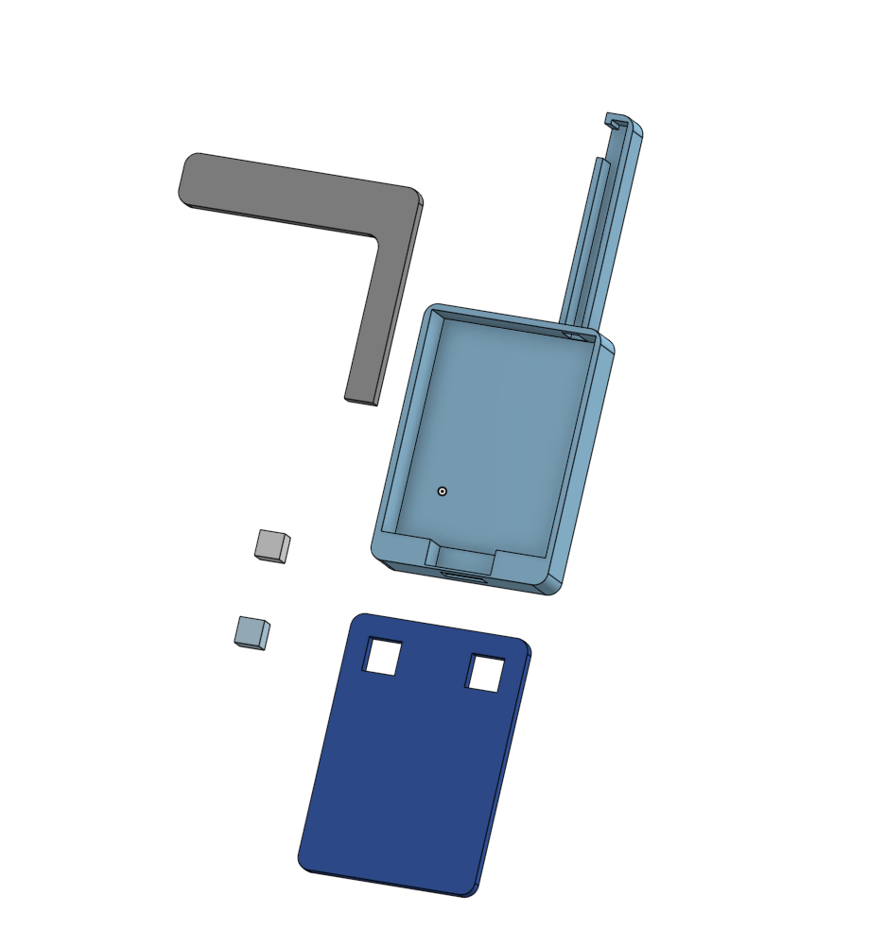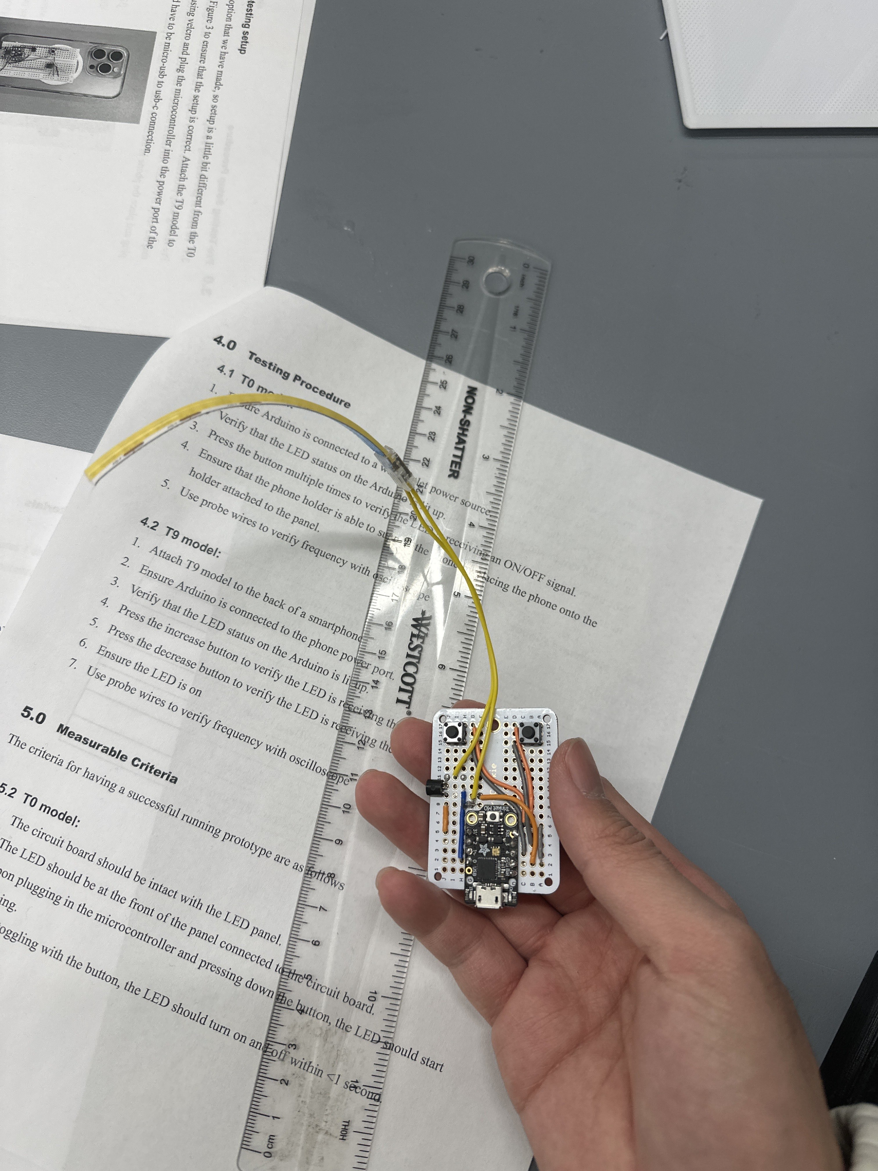

We are currently enhancing the electronic components of our project by transitioning the circuitry from a breadboard to a dedicated circuit board. In conjunction with these modifications, we have optimized the circuit design, resulting in a more compact overall footprint. A new housing has been specifically designed to accommodate the reduced size of the circuit.

Please note that this project is still under development and may not be finalized by ECE Day.